

Axisymmetric Finite Element Analysis: Local Linear Elastic Stress Concentrations Around a Spherical Cavity

MECH 514: Finite Element Analysis
Instructor: Prof. Mattia Bacca

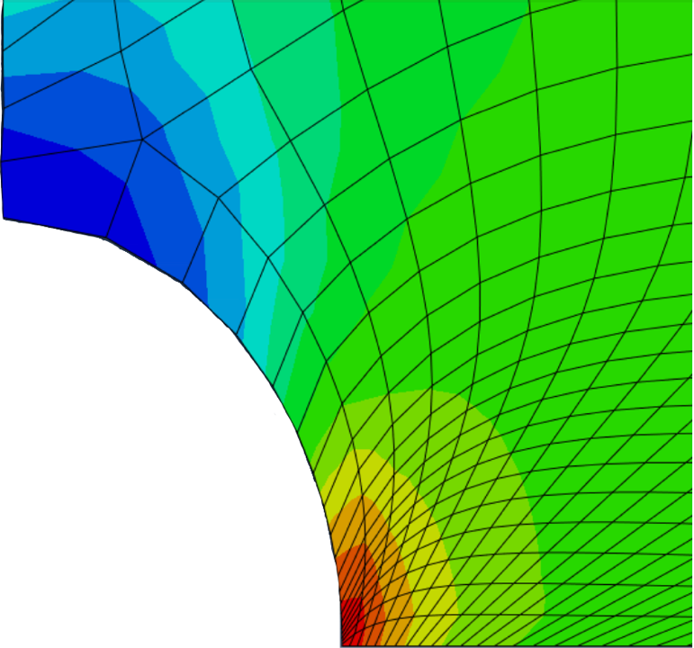

Prepared by: Christopher Augustin Coluni
Student ID: 10733053

Submitted on: December 20th, 2025

Introduction & Methodology
The finite element (FE) problem to be analysed in this report is an axially loaded, three-dimensional, and linearly elastic cube specimen with a spherical cavity located at its geometric center (Figure 1). Given the symmetrical attributes, the problem can be better described as a solid of revolution that is deformed symmetrically with respect to its axis of symmetry. This mathematical principle enables one to simplify the scope of the analysis by focusing on just a specific portion of the overall geometry as demonstrated in Figure 2.
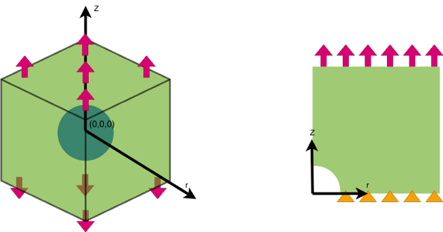
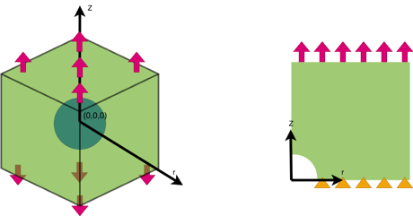

Figure 1: 3D Geometry Figure 2: Reduced 2D Geometry

The objective of this report will be to write a unique Matlab script capable of solving the stress and displacement components of this common solid mechanics problem and to perform a validation study on its performance. To validate the Matlab script, it will be compared against a numerical approach, based on classical solid mechanics formulations reported in literature, and commercially available Abaqus software. To ensure an unbiased comparison between the digital FE approaches, similar meshing techniques and convergence protocols will be performed. To solve the problem, a few important FE assumptions and simplifications will be incorporated across all three solving methods. To establish a uniform far-field stress $σ_{∞}$ of 100MPa, the square edge length will be 20x larger than the cavity radius (2m & 0.1m). To assume material linear elasticity, the ratio between $σ_{∞}$ and the elastic modulus $E ($90Gpa) is less than 0.1. Lastly, an axisymmetric FE solving approach will be employed due to symmetry which means that the field variables of strain, axial displacement and stress components are independent of the angle $θ$ and do not vary with circumferential position [1].

The MATLAB script utilises a bilinear quadrilateral structured mesh, with element sizes in the axial and radial directions that vary via power law spacing and is solved via reduced integration (Figure 3). The meshgrid is comprised of 60x60 elements with each node having two degrees of freedom (DOF). Different tensile force magnitudes are set at each axial DOF across all radial nodes positioned along z = 2m. This is because nodes at different radial positions away from the axis of symmetry contribute different surface areas, requiring an adjustment in the applied nodal forces at each node. At z = 0m, all radial nodes are fixed axially. The power law spacing coefficient determined via convergence is 0.55, with the smallest elements being closest to the constrained cavity edge. The difference between the smallest to largest element sizes is 52. Due to axisymmetry, hoop strain must be finite, requiring radial displacements along the axis of symmetry to be zero. This rule forces no gauss points to have a radial coordinate of zero in order for reduced integration to yield zero singularities.

The Abaqus FE simulation utilises a quadrilateral structured mesh, with elements sizes in the axial and radial directions being varied through single edge biasing and is solved via reduced integration (Figure 4). No automatic curve control is applied to the mesh. Similarly to the Matlab meshgrid, each of the edges have 60 elements each with bias ratios of 60. The recorded difference between the smallest to largest element sizes is 47, with the smallest elements being closest to the constrained cavity. At z = 0m, all radial nodes are fixed axially and at z =2m, all radial nodes have an applied tensile traction of $σ_{∞}$.

The numerical approach involves using the displacement and stress equations found in section 5.4.8 of Allan F. Bower’s Applied Mechanics of Solids electronic textbook, along with the assumptions located in the Appendix [2].
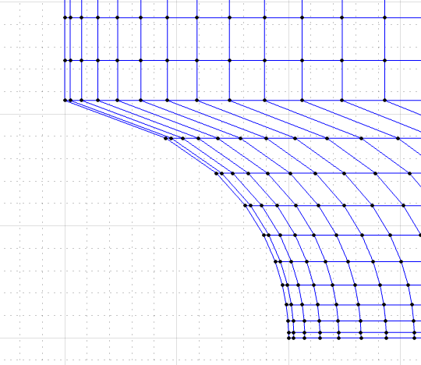
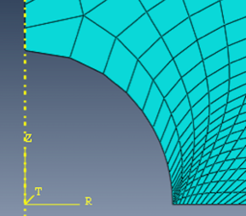

Figure 3: Matlab structured mesh Figure 4: Abaqus structured mesh
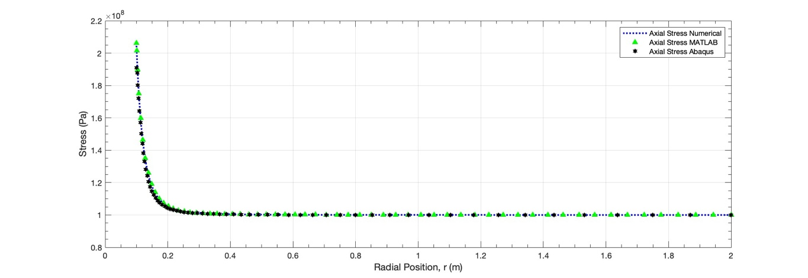
Results

Figure 5: Plot of the axial stress $σ_{zz}$ versus radial position for different analysis techniques

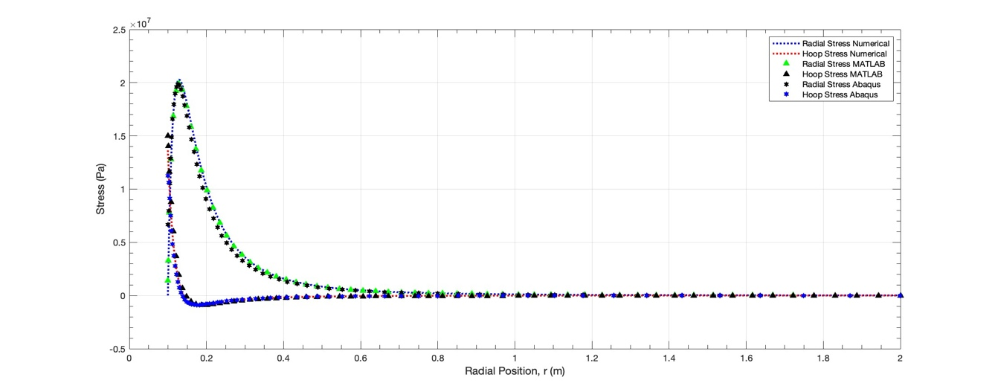

Figure 6: Plot of the radial stress $σ_{rr}$ and hoop stress $σ_{θθ}$versus radial position for different analysis techniques

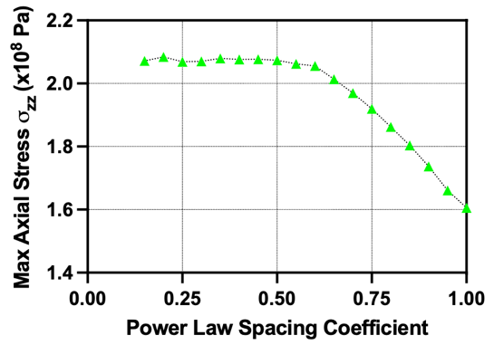
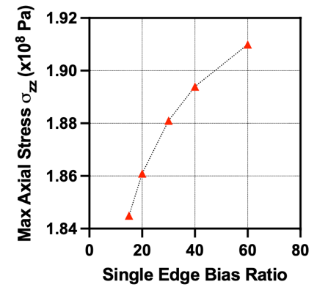

Figure 7: Graphical visualisation of the convergence studies for the bias ratio and the power law spacing coefficients used in the optimization of the Abaqus mesh and the Matlab mesh respectively

The maximum axial displacements along the vertical axis of symmetry from z = 0.1m to z = 2m were found to be 0.0033m, 0.0033m and 0.0032m for the numerical, Matlab script and Abaqus methods respectively. Additional stress results can be found in Table 1, located in the Appendix. Additionally, the lack of a plateau in the single edge bias ratio convergence study is due to self-intersecting edges in the mesh as the bias ratio becomes too large. Despite this lack of plateau, minimal changes to the maximum axial stress magnitudes can be observed as the bias ratio is increased from 15 to 60.

Validation and Limitations
The FE method is an approximation by nature, with an objective to provide usable results at reasonable computational cost and effort. To perform the comparative assessment of the Matlab FE script with the numerical and Abaqus solutions, a percent error/difference range of <5-10% is chosen to be acceptable for the outputted stress components and axial displacements. It is important to note that before validation, the two digital FE simulations must have passed a mesh convergency test as shown in Figure 7. A percent error analysis method is applied when comparing digital FE methods to literature, as the theoretical formulations are considered to be accepted values. Conversely, a percent difference analysis method is applied when comparing Matlab to Abaqus as an accepted value is not known between the two techniques.
Parameter | Percentage Error Matlab | Percentage Error Abaqus
$$σ_{rr, max}$$ | 1.67% | 2.12%
$$σ_{θθ, max}$$ | 10.19% | 17.53%
$$σ_{zz, max}$$ | 0.83% | 6.60%
vertical displacement (max) | 0% | 3.03%
Table 2: Percentage error between Matlab and Abaqus derived displacement and stress data compared to the numerical solution

Apart from the maximum hoop stress, the low percent error between the Matlab script and the numerical solution implies that the code is capable of handling this specific axisymmetric solid mechanics problem correctly. In addition, it also helps in validating the proper execution and incorporation of the axisymmetric specific boundary conditions and radial nodal loading conditions, which were used to simplify the 3D case into a less computationally demanding 2D alternative. To improve the variability with the hoop stress, increases in the number of quadrilateral elements can be tested (>60), along with improved curvature meshing through the use of 8 or 9 node quadratic elements. However, the current quad-dominated structured mesh already has minimal element skewness near the constrained region of interest, with only larger aspect ratio elements (determined qualitatively) located at the upper region of the cavity (Figure 4).
Parameter | Percentage Difference
$$σ_{rr, max}$$ | 0.18%
$$σ_{θθ, max}$$ | 28.78%
$$σ_{zz, max}$$ | 7.65 %
vertical displacement (max) | 3.08%
Table 3: Percentage difference between Matlab derived displacement and stress data compared to Abaqus

The increased percent error and percent difference for Abaqus, when compared to both the numerical and Matlab methods respectively, are due to the differences in mesh styles. Despite having the same bilinear quadrilateral structured geometry, the single edge biasing feature could not replicate the power law spacing behaviour. Although the two digital FE techniques had similar maximum element size differences of 47x and 52x, the power law model had a much more aggressive sizing function, with a greater proportion of smaller elements found near the cavity edge. Additionally, as shown in Figure 4, larger quadrilateral aspect ratios are found near the constrained cavity edge in the Abaqus mesh due to how the software automatically reshapes elements along curved boundaries. Element skewness and acute interior angles within the elements seem to dominate the region around the cavity, which have been studied to impact solution quality [3].

With this being said, the results between the Matlab and Abaqus methods limits the ability to classify one as being better performing due to mesh inconsistencies. However, it can be said that simpler meshing styles that can be easily coded in Matlab serve as a challenge to fully recreate in Abaqus. Improvements to the Abaqus mesh can be explored through curvature control or by incorporating a mesh partition. A mesh partition would allow two different quadrilateral structured meshes to be conjoined together, which is visually happening with the Matlab mesh (Figure 3). In short, both the Matlab script and the Abaqus FE method produced percentage error values within the specified error threshold for the radial stress, axial stress and maximum vertical displacements when compared to accepted values from literature. Although the two meshing styles for these methods were not exactly the same, for this specific validation study, it can be said that the Matlab script mesh outperformed Abaqus in terms of reducing percent error.

[1] S.P. Timoshenko, J.N. Goodier (1970). Theory of Elasticity (3rd ed.). McGraw-Hill.
[2] A. F. Bower, “Applied Mechanics of Solids (A.F. Bower) Section 5.4: 3D solutions in elasticity.” Accessed: Dec. 20, 2025. [Online]. Available: https://solidmechanics.org/Text/Chapter5_4/Chapter5_4.php#Sect5_4_8 [3] Y. Zhang, C. Bajaj, and G. Xu, “Surface Smoothing and Quality Improvement of Quadrilateral/Hexahedral Meshes with Geometric Flow,” Commun Numer Methods Eng, vol. 25, no. 1, pp. 1–18, Nov. 2007, doi: 10.1002/cnm.1067.
Appendix
Axial Displacement Equation:

$$u_{i}=\frac{\left(1+υ\right)σ_{0}}{E}\left\{1+\frac{5}{7-5υ}\left(1-2ν+\frac{3}{5}\frac{a^{2}}{R^{2}}\right)\frac{a^{3}}{R^{3}}\right\}δ_{i3}x_{3}+\frac{\left(1+υ\right)σ_{0}}{E}\left(-\frac{υ}{(1+υ)}-\frac{6-5ν}{7-5ν}\frac{a^{3}}{R^{3}}+\frac{15}{2(7-5υ)}\frac{a^{3}}{R^{3}}\left(\frac{a^{2}}{5R^{2}}+\frac{{x_{3}}^{2}}{R^{2}}-\frac{a^{2}{x_{3}}^{2}}{R^{4}}\right)\right)x_{i}$$

Below is the general stress component equation for $σ_{rr}, σ_{θθ}$ and $, σ_{zz}$. When solving for $σ_{rr}$ and $σ_{θθ}$ the first and last terms in the equation are equal to zero due to $i≠j$ in the Kronecker delta.

$$\frac{σ_{ij}}{σ_{0}}=δ_{i3}δ_{i3}\left\{1+\frac{5\left(1-2v\right)}{\left(7-5υ\right)}\frac{a^{3}}{R^{3}}+\frac{3}{\left(7-5υ\right)}\frac{a^{5}}{R^{5}}\right\}+\frac{3}{2\left(7-5υ\right)}\frac{a^{3}}{R^{3}}δ_{ij}\left\{\left(5v-2\right)+5\left(1-2v\right)\frac{{x_{3}}^{2}}{R^{2}}+\frac{a^{2}}{R^{2}}-5\frac{a^{2}{x_{3}}^{2}}{R^{4}}\right\}+\frac{3}{2(7-5υ)}\frac{a^{3}x_{i}x_{j}}{R^{5}}\left\{\left(6-5v\right)-25\frac{{x_{3}}^{2}}{R^{2}}-5\frac{a^{2}}{R^{2}}+35\frac{{x_{3}}^{2}a^{2}}{R^{4}}\right\}-\frac{15(1-v)}{(7-5υ)}\frac{{(δ_{i3}x_{j}+δ_{j3}x_{i})a}^{3}x_{3}}{R^{5}}$$

$$x1=rcosθ, x2=rsinθ and x3=z=0$$
$$R= \sqrt{{x1}^{2}+{x2}^{2}+{x3}^{2}}$$
$Let θ=0 rad, as we are interested in solving for the variations in stresses along the radial path z=0$

Parameter | Numerical | MATLAB | Abaqus
$$σ_{rr, min}$$ | $$-2.775∙{10}^{-9} Pa$$ | $$451.32 Pa$$ | $$-1049 Pa$$
$$σ_{rr, max}$$ | $$2.027∙{10}^{7} Pa$$ | $$1.993∙{10}^{7} Pa$$ | $$1.984∙{10}^{7} Pa$$
$$σ_{θθ, min}$$ | $$-8.961∙{10}^{5} Pa$$ | $$-8.758∙{10}^{5} Pa$$ | $$-8.837∙{10}^{5} Pa$$
$$σ_{θθ, max}$$ | $$1.363∙{10}^{7} Pa$$ | $$1.502∙{10}^{7} Pa$$ | $$1.124∙{10}^{7} Pa$$
$$σ_{zz, min}$$ | $$1.000∙{10}^{8} Pa$$ | $$9.997∙{10}^{7} Pa$$ | $$9.999∙{10}^{7} Pa$$
$$σ_{zz, max}$$ | $$2.045∙{10}^{8} Pa$$ | $$2.062∙{10}^{8} Pa$$ | $$1.910∙{10}^{8} Pa$$
Maximum vertical displacement along path $r=0$ | 0.0033 m | 0.0033 m | 0.0032 m
Table 1: Recorded maximum and minimum stress values for all three axisymmetric components and vertical displacements for different FE solving methods.

Percentage Error Equation:
$$\% Error= \frac{\left|experimental value-accepted value\right|}{accepted value}$$
Percentage Difference Equation:
$$\% Difference= \frac{\left|value A- value B\right|}{\left|\frac{value A+value B}{2}\right|}$$

Matlab FEA Script

E = 60e9; % Material Elastic Modulus
v = 0.3; % Poisson Ratio

nr = 60; % number of elements along radial position (61 nodes)
nz = 60; % number of elements along vertical position z

Ri0 = 0.1; % quarter circle radius (m)
Ro = 2; % max outer radius (m)
Lz = 2; % max height (m)

pr = 0.55; % power law spacing coefficient
pz = 0.55; % power law spacing coefficient

% Establishing a 1xnz+1 vector for all the different nodes in z
z_lin = linspace(0, 1, nz+1);
z_nodes = Lz*(z_lin).^(1/pz); % variable nodal spacing, nodes along z are closer to each other near z = 0.1

rn = zeros(nz+1, nr+1);
zn = zeros(nz+1, nr+1);

for k = 1:nz+1
z = z_nodes(k);

if z <= Ri0 % if the coordinate for z falls either inside or on edge of the radius, we need to shift the position of the r nodal position so it starts outside of the cavity
r_offset = sqrt(Ri0^2 - z^2);
else
r_offset = 0; % if z nodal coordinate is beyond the radius, then no need to shift r nodal position
end

r_lin = linspace(0,1,nr+1); % Establishing a 1xnz+1 vector for all the different nodes in z
r_nodes = r_lin.^(1/pr); % variable nodal spacing, nodes in r are closer to each other near r = 0.1

rn(k,:) = r_offset + r_nodes*(Ro - r_offset); % shifted r nodal coordinates (physical coordinate position (r,z)
zn(k,:) = z; % no need to shift coordinates of the z nodes (physical coordinate position (r,z)
end

N = (nr+1)*(nz+1); % total number of nodes within the Ro x Lz square geometry (minus the quarter circle)

K = zeros(2*N, 2*N);

C = E / ((1+v)*(1-2*v));

Em = C * [ (1-v), v, v, 0;
v, (1-v), v, 0;
v, v, (1-v), 0;
0, 0, 0, (1-2*v)/2 ];

T = [1, 0, 0, 0;
0, 0, 0, 1;
0, 1, 1, 0];

wv = [0.5556, 0.8889];

g(1,:) = 0.77*[-1,-1]; w(1) = wv(1)*wv(1);
g(2,:) = 0.77*[0,-1]; w(2) = wv(2)*wv(1);
g(3,:) = 0.77*[1,-1]; w(3) = wv(1)*wv(1);
g(4,:) = 0.77*[-1,0]; w(4) = wv(1)*wv(2);
g(5,:) = 0.77*[0,0]; w(5) = wv(2)*wv(2);
g(6,:) = 0.77*[1,0]; w(6) = wv(1)*wv(2);
g(7,:) = 0.77*[-1,1]; w(7) = wv(1)*wv(1);
g(8,:) = 0.77*[0,1]; w(8) = wv(2)*wv(1);
g(9,:) = 0.77*[1,1]; w(9) = wv(1)*wv(1);

check = sum(w);

% {ee} = [B]{u} where the [B] matrix relates nodal displacements to strain
% The Bstore will be storing every [B] strain-displacment matrix for every
% Gauss Point for every element found in the mesh setup earlier.
%{ee} = 4x1 strain vector (eer, eetheta, eez, shear rate rz)
%[B] = 4 x 8 matrix (why 8, xi1, eta1, xi2, eta2, xi3, eta3, xi4, eta4) in
%the natural coordinates
%{u} = displacements in physical coordinates (r1, z1, r2, z2, r3, z3, r4,
%z4)

Bstore = zeros(4, 8, nz, nr, 9); % The 9 here is because we will have 9 gauss points

for er = 1:nr
for ez = 1:nz
i = (ez-1)*(nr+1) + er;
j = i + nr + 1;

r1 = rn(ez,er); r2 = rn(ez,er+1); r3 = rn(ez+1,er); r4 = rn(ez+1,er+1);
z1 = zn(ez,er); z2 = zn(ez,er+1); z3 = zn(ez+1,er); z4 = zn(ez+1,er+1);

Kq = zeros(8,8); %stiffness matrix dimensions for a given
quadrilateral element w/ 2DOFs per node (8x8)

for gg = 1:9
xx = g(gg,1); % stored in row
yy = g(gg,2); % stored in column

Nxx = [-0.25*(1-yy), 0.25*(1-yy), -0.25*(1+yy), 0.25*(1+yy)];
%shape function derived with respect to x
Nyy = [-0.25*(1-xx), -0.25*(1+xx), 0.25*(1-xx), 0.25*(1+xx)];
%shape function derived with respect to y
Nf = 0.25*[(1-xx)*(1-yy), (1+xx)*(1-yy), (1-xx)*(1+yy), (1+xx)*(1+yy)]; % will be used for the eethata = u/r calculation

J = [Nxx*[r1;r2;r3;r4], Nxx*[z1;z2;z3;z4];
Nyy*[r1;r2;r3;r4], Nyy*[z1;z2;z3;z4]];

dJ = det(J);
iJ = inv(J);
A = T * [iJ, zeros(2,2); zeros(2,2), iJ];

G = [Nxx(1) 0 Nxx(2) 0 Nxx(3) 0 Nxx(4) 0;
Nyy(1) 0 Nyy(2) 0 Nyy(3) 0 Nyy(4) 0;
0 Nxx(1) 0 Nxx(2) 0 Nxx(3) 0 Nxx(4);
0 Nyy(1) 0 Nyy(2) 0 Nyy(3) 0 Nyy(4)];

Bh = A * G; %this is a 3x8 matrix that is comprised of T * (the 4x4 inverse J mtx) * G
r_min = 1e-6; % with the r not being physically constrained by boundary conditions, we cant have gauss points that are directly positioned on the axis of symmetry (r = 0)
r_gauss = max(Nf*[r1; r2; r3; r4], r_min);
Btheta = [Nf(1),0,Nf(2),0,Nf(3),0,Nf(4),0] / r_gauss; %Btheta is the eetheta entry of the {ee} vector, dividing it by r_gauss yields u/r evaluated at the gauss points
B = [Bh(1,:); Btheta; Bh(2,:); Bh(3,:)]; % 4 x 8

Bstore(:,:,ez,er,gg) = B;

dKq = w(gg) * 2 * pi * r_gauss * B' * Em * B * dJ;
Kq = Kq + dKq;
end

edofs = [2*i-1,2*i,2*(i+1)-1,2*(i+1),2*j-1,2*j,2*(j+1)-1,2*(j+1)]; % Node numbering
K(edofs,edofs) = K(edofs,edofs) + Kq; % This is how we organise and locate an entry within with the stiffness matrix (need row ID and Column ID to extract one value)
end
end

% Setting up the axi_symmetric boundary conditions
% @ z = 0 (the lower wall surface) we need to fix vertical displacement.
% The nodes at this level can only move left and right along r

% Bottom surface (z=0):
irfix = 1:nr+1;
izfix = 1;
fixed_bottom_dofs = 2*irfix; % Fix v (z-direction displacement)

% Setup the traction force (uniform pressure (Pa = F/A) along the top of
% the structure) --> basically applying the load to all of the radial nodes
% at the top most vertical z value (r nodes @ z = 2).

f = zeros(2*N,1);
p = 1e8;

top_surface_node_number = nz*(nr+1)+1 : (nz+1)*(nr+1);
% this line finds the first and last node numbers when z=2 (max height)

top_surface_coord = rn(nr+1,:); %geometric coordinates of the nodes in top_surface

% Apply nodal forces
% Note, equal forces being applied to all nodes is incorrect
% Nodes @ different radii contribute different surface areas

for i = 1:length(top_surface_node_number)-1
n1 = top_surface_node_number(i);
n2 = top_surface_node_number(i+1);
r1 = top_surface_coord(i);
r2 = top_surface_coord(i+1);
edge_midpoint_coord = 0.5*(r1 + r2);
dr = r2 - r1;

ftotal = p * (2 * pi * edge_midpoint_coord * dr);

force_at_node = ftotal / 2;

f(2*n1) = f(2*n1) + force_at_node; % applying the vertical load at the node (but specifically the axial DOF, not radial DOF)
f(2*n2) = f(2*n2) + force_at_node;
end

%Solve

free_dofs = setdiff(1:2*N, fixed_bottom_dofs); % everything but the fixed dofs

u = zeros(2*N,1); % recall 2N = 2(nr+1)*(nz+1) x 1 (column vector)

u(free_dofs) = K(free_dofs, free_dofs) \ f(free_dofs); % essentially is taking inverse of K times F

nodal_stress = zeros(N, 4); % storage format = (nr+1)*(nz+1) x 4 (each of the 4 columns are for the different stress components)
nodal_count = zeros(N, 1); % number of nodes (column vector)

for er = 1:nr % 1 - 60
for ez = 1:nz % 1 - 60
i = (ez-1)*(nr+1) + er;
j = i + nr + 1;
nodes = [i, i+1, j, j+1]; % node numbering for a single bilinear quad element

% Extracting axial & radial displacement information for a given element
u1 = u(2*i-1); % recall previous numbering edofs = [2*i-1,2*i,2*(i+1)-1,2*(i+1),2*j-1,2*j,2*(j+1)-1,2*(j+1)];
v1 = u(2*i);
u2 = u(2*(i+1)-1);
v2 = u(2*(i+1));
u3 = u(2*j-1);
v3 = u(2*j);
u4 = u(2*(j+1)-1);
v4 = u(2*(j+1));
u_elem = [u1;v1;u2;v2;u3;v3;u4;v4]; % nodal displacements contained in a 8x1 vector

stress_elem = zeros(4,1); % The average stresses (for all 4 compoenents) coming from the calculation of all 9 gauss points)
for gg = 1:9
ee = Bstore(:,:,ez,er,gg) * u_elem;
% with ee, we solve for the strain components (a 4x1 vector).
% ee = (4x8) * (8x1) = 4x1 ... this is solved per gauss point
% per element. we will have 9 of these 4x1's

stress_elem = stress_elem + w(gg)/4 * Em * ee;
% This is the final 4x1 stress vector for a given element which
% is made up of 9 4x1 stress vectors added together (being
% adjusted based on the relative weights of their gauss points)
end

% Add to all nodes of this element
for n = nodes
nodal_stress(n,:) = nodal_stress(n,:) + stress_elem';
% here we store the stresses per node (we transpose the stress
% vector so it is now 1x4. So 1 node has each of the 4
% respective stresses

nodal_count(n) = nodal_count(n) + 1;
end
end
end

nodal_stress = nodal_stress ./ nodal_count;

figure(1) % This will showcase undeformed nodal positions and highlight boundary conditions
hold on;
grid on;
grid minor
title('Mesh Nodes','fontsize',16)

plot(rn, zn, 'ko', 'MarkerSize',2) % nodes before displacements
plot(rn(izfix,irfix), zn(izfix,irfix), 'rs', 'MarkerSize',6) % fixed nodes (bottom layer)
plot(rn(end,:), zn(end,:), 'gv', 'MarkerEdgeColor',[0,0.7,0], 'MarkerSize',6) % loaded nodes (top layer)
axis equal

% Stress Plots & Displacement Plots
% MATLAB DATA
bottom_edge_nodes = 1:nr+1;
r_bot = rn(1,:);

axial_edge_nodes = 1:nr+1:N;
z_axial = zn(:, 1);
vertical_displacement = u(2*axial_edge_nodes);

sigma_rr = nodal_stress(bottom_edge_nodes, 1);
sigma_theta = nodal_stress(bottom_edge_nodes, 2);
sigma_zz = nodal_stress(bottom_edge_nodes, 3);

disp(min(sigma_rr)); disp(max(sigma_rr));
disp(min(sigma_theta)); disp(max(sigma_theta));
disp(min(sigma_zz)); disp(max(sigma_zz));
disp(max(vertical_displacement));

% IMPORTED ABAQUS PATH & STRESS DATA

abaqus_radial_path_coordinates = [0, 2.15E-03, 4.46E-03, 6.94E-03, 9.59E-03, 1.24E-02, 1.55E-02, ...
1.88E-02, 2.23E-02, 2.6E-02, 3E-02, 3.44E-02, 3.9E-02, 4.39E-02, ...
4.93E-02, 5.5E-02, 6.11E-02, 6.76E-02, 7.46E-02, 8.21E-02, 9.02E-02, 9.88E-02, ...
1.08E-01, 1.18E-01, 1.29E-01, 1.4E-01, 1.52E-01, 1.65E-01, 1.79E-01, 1.94E-01, ...
2.11E-01, 2.28E-01, 2.46E-01, 2.66E-01, 2.88E-01, 3.1E-01, 3.35E-01, 3.61E-01, ...
3.89E-01, 4.19E-01, 4.52E-01, 4.86E-01, 5.23E-01, 5.63E-01, 6.06E-01, 6.51E-01, ...
7E-01, 7.53E-01, 8.09E-01, 8.69E-01, 9.34E-01, 1.00303, 1.07726, 1.15683, 1.24211, ...
1.33352, 1.4315, 1.53653, 1.64909, 1.76975, 1.89908];

abaqus_zz_values = [1.91E+08, 1.878E+08, 1.802E+08, 1.72E+08, 1.643E+08, 1.571E+08, ...
1.503E+08, 1.44E+08, 1.383E+08, 1.33E+08, 1.283E+08, 1.242E+08, 1.206E+08, ...
1.175E+08, 1.148E+08, 1.125E+08, 1.106E+08, 1.089E+08, 1.075E+08, 1.063E+08, ...
1.053E+08, 1.044E+08, 1.037E+08, 1.031E+08, 1.026E+08, 1.022E+08, 1.018E+08, ...
1.015E+08, 1.013E+08, 1.011E+08, 1.009E+08, 1.007E+08, 1.006E+08, 1.005E+08, ...
1.004E+08, 1.004E+08, 1.003E+08, 1.003E+08, 1.002E+08, 1.002E+08, 1.002E+08, ...
1.001E+08, 1.001E+08, 1.001E+08, 1.001E+08, 1.001E+08, 1.001E+08, 1.001E+08, ...
1E+08, 1E+08, 1E+08, 1E+08, 1E+08, 1E+08, 1E+08, 1E+08, 1E+08, 1E+08, 1E+08, ...
9.999E+07, 9.999E+07];

abaqus_rr_values = [6.68E+06, 7.966E+06, 1.053E+07, 1.288E+07, 1.488E+07, 1.659E+07, 1.796E+07, ...
1.896E+07, 1.959E+07, 1.984E+07, 1.976E+07, 1.937E+07, 1.873E+07, 1.789E+07, ...
1.69E+07, 1.582E+07, 1.468E+07, 1.351E+07, 1.235E+07, 1.122E+07, 1.013E+07, ...
9.1E+06, 8.129E+06, 7.227E+06, 6.396E+06, 5.635E+06, 4.944E+06, 4.321E+06, ...
3.762E+06, 3.263E+06, 2.821E+06, 2.431E+06, 2.087E+06, 1.787E+06, 1.525E+06, ...
1.298E+06, 1.102E+06, 9.326E+05, 7.872E+05, 6.627E+05, 5.564E+05, 4.66E+05, ...
3.892E+05, 3.242E+05, 2.692E+05, 2.229E+05, 1.839E+05, 1.512E+05, 1.237E+05, ...
1.007E+05, 8.148E+04, 6.538E+04, 5.19E+04, 4.062E+04, 3.114E+04, 2.316E+04, ...
1.646E+04, 1.071E+04, 6.171E+03, 1.626E+03, -1.049E+03];

abaqus_theta_values = [1.124E+07, 1.063E+07, 9.123E+06, 7.488E+06, 6.074E+06, 4.827E+06, 3.736E+06, ...
2.787E+06, 1.974E+06, 1.287E+06, 7.2E+05, 2.599E+05, -1.015E+05, -3.794E+05, ...
-5.823E+05, -7.255E+05, -8.159E+05, -8.668E+05, -8.837E+05, -8.76E+05, -8.494E+05,...
-8.086E+05, -7.598E+05, -7.038E+05, -6.466E+05, -5.873E+05, -5.304E+05, -4.746E+05, ...
-4.229E+05, -3.74E+05, -3.297E+05, -2.89E+05, -2.526E+05, -2.198E+05, -1.91E+05, ...
-1.654E+05, -1.431E+05, -1.236E+05, -1.068E+05, -9.222E+04, -7.973E+04, -6.905E+04, ...
-5.995E+04, -5.224E+04, -4.572E+04, -4.025E+04, -3.567E+04, -3.186E+04, -2.872E+04, ...
-2.616E+04, -2.409E+04, -2.246E+04, -2.121E+04, -2.031E+04, -1.973E+04, -1.945E+04, ...
-1.946E+04, -1.987E+04, -2.043E+04, -2.206E+04, -2.346E+04];

disp(min(abaqus_rr_values)); disp(max(abaqus_rr_values));
disp(min(abaqus_theta_values)); disp(max(abaqus_theta_values));
disp(min(abaqus_zz_values)); disp(max(abaqus_zz_values));

% NUMERICAL SOLUTION for stresses and displacements- Converted Equations from the Applied Mechanics of
% Solids by Allan F. Bower (Section 5.4.8)

a = 0.1;
sig_0 = p;
v = 0.3;
theta = 0; % can be any angle, but for simplicity, keep it at zero

r = linspace(0.1, 2, 1000);
x1 = r * cos(theta); % this is the radial position
x2 = r * sin(theta); % this is zero
x3 = zeros(size(r)); % we plot stress along the radial positions at axial height of z = 0 (so x3 = 0 everywhere)

R = sqrt(x1.^2 + x2.^2 + x3.^2);
% Solving for the radial stress component numerical_sigma_rr

B = 3/(2*(7-5*v)) * (a^3./R.^3) .* ((5*v-2) + 5*(1-2*v).*(x3.^2./R.^2) + (a^2./R.^2) - 5*(a^2.*x3.^2./R.^4));
C = 3/(2*(7-5*v)) * (a^3.*x1.*x1./R.^5) .* ((6-5*v) - 25*(x3.^2./R.^2) - 5*(a^2./R.^2) + 35*(x3.^2.*a^2./R.^4));
numerical_sigma_rr = sig_0 * (B + C);

% Solving for the hoop stress component numerical_sigma_theta

B = 3/(2*(7-5*v)) * (a^3./R.^3) .* ((5*v-2) + 5*(1-2*v).*(x3.^2./R.^2) + (a^2./R.^2) - 5*(a^2.*x3.^2./R.^4));
C = 3/(2*(7-5*v)) * (a^3.*x2.*x2./R.^5) .* ((6-5*v) - 25*(x3.^2./R.^2) - 5*(a^2./R.^2) + 35*(x3.^2.*a^2./R.^4));

numerical_sigma_theta = sig_0 * (B + C);

% Solving for the axial stress component numerical_sigma_zz

A = 1 + (5*(1-2*v))/(7-5*v) * (a^3./R.^3) + 3/(7-5*v) * (a^5./R.^5);
B = 3/(2*(7-5*v)) * (a^3./R.^3) .* ((5*v-2) + 5*(1-2*v).*(x3.^2./R.^2) + (a^2./R.^2) - 5*(a^2.*x3.^2./R.^4));
C = 3/(2*(7-5*v)) * (a^3.*x3.*x3./R.^5) .* ((6-5*v) - 25*(x3.^2./R.^2) - 5*(a^2./R.^2) + 35*(x3.^2.*a^2./R.^4));
D = -15*(1-v)/(7-5*v) * (2)*(a^3.*x3./R.^5);

numerical_sigma_zz = sig_0 * (A + B + C + D);

disp(min(numerical_sigma_rr)); disp(max(numerical_sigma_rr));
disp(min(numerical_sigma_theta)); disp(max(numerical_sigma_theta));
disp(min(numerical_sigma_zz)); disp(max(numerical_sigma_zz));

figure(2)
hold on;
box on;

plot(r, numerical_sigma_zz, 'b:','LineWidth', 2);

plot(r_bot, sigma_zz, 'g^', 'MarkerSize', 6, 'MarkerFaceColor', 'g');

plot((abaqus_radial_path_coordinates + 0.1), abaqus_zz_values, 'kh', 'MarkerSize', 6, 'MarkerFaceColor', 'k');

xlabel('Radial Position, r (m)', 'FontSize',12);
ylabel('Stress (Pa)', 'FontSize',12);
legend('Axial Stress Numerical','Axial Stress MATLAB','Axial Stress Abaqus');
set(gca, 'XMinorTick', 'on');
set(gca, 'YMinorTick', 'on');
grid on;

figure(3)
hold on;
box on;

plot(r, numerical_sigma_rr, 'b:', 'LineWidth', 2);
plot(r, numerical_sigma_theta, 'r:', 'LineWidth', 2);

plot(r_bot, sigma_rr, 'g^', 'MarkerSize', 6, 'MarkerFaceColor', 'g');
plot(r_bot, sigma_theta, 'k^', 'MarkerSize', 6, 'MarkerFaceColor', 'k');

plot((abaqus_radial_path_coordinates + 0.1), abaqus_rr_values, 'kh', 'MarkerSize', 6, 'MarkerFaceColor', 'k');
plot((abaqus_radial_path_coordinates + 0.1), abaqus_theta_values, 'bh', 'MarkerSize', 6, 'MarkerFaceColor', 'b');

xlabel('Radial Position, r (m)', 'FontSize',12);
ylabel('Stress (Pa)', 'FontSize',12);
legend('Radial Stress Numerical', 'Hoop Stress Numerical','Radial Stress MATLAB', 'Hoop Stress MATLAB', 'Radial Stress Abaqus', 'Hoop Stress Abaqus');
set(gca, 'XMinorTick', 'on');
set(gca, 'YMinorTick', 'on');
grid on;

% numerical displacement equation (Allan F. Bower)
sig_0 = p;
E = 60e9;
v_ = 0.3;
r_ = 0;
z = 2;
a = Ri0;
R = (r_^2 + z^2)^0.5;

displacement = ((1+v)*sig_0/E) * (1 + 5/(7-5*v) * (1-2*v+(3*a^2)/(5*R^2)) * (a^3/R^3)) * z ...
+ (1+v)*sig_0/E * ( -v/(1+v) - ((6-5*v)*a^3) / ((7-5*v)*R^3) ...
+ (15*a^3)/(2*(7-5*v)*R^3) * ( a^2/(5*R^2) + z^2/R^2 - (a^2*z^2)/R^4))*z;

display(displacement);

% MATLAB MESH CONVERGENCY TEST
% These values are actually plotted using PRISM Graphpad for better
% visualisation

figure(4)
p_factor = [0.15, 0.20, 0.25, 0.30, 0.35, 0.40, 0.45, 0.50, 0.55, 0.60, 0.65, 0.70, 0.75, 0.80, 0.85, 0.90, 0.95, 1.00];
max_sigma_zz_matlab = [2.0715, 2.0841, 2.0687, 2.0702, 2.0799, 2.0765, 2.0772, 2.074, 2.0626, 2.0556, 2.0138, 1.970, 1.9198, 1.8625, 1.8035, 1.737, 1.661, 1.606];
plot(p_factor, max_sigma_zz_matlab, 'ro', 'MarkerSize', 3, 'MarkerFaceColor', 'r');
xlabel('Power Law Spacing Coefficient', 'FontSize',12);
ylabel('Max Axial Stress (Pa)', 'FontSize',12);

% Abaqus MESH CONVERGENCY TEST
% These values are actually plotted using PRISM Graphpad for better
% visualisation

figure(5)
bias_coefficient = [15, 20, 30, 40, 60];
max_sigma_zz_abaqus = [1.845, 1.861, 1.881, 1.894, 1.910];
plot(bias_coefficient, max_sigma_zz_abaqus, 'ro', 'MarkerSize', 3, 'MarkerFaceColor', 'r');
xlabel('Power Law Spacing Coefficient', 'FontSize',12);
ylabel('Max Axial Stress (Pa)', 'FontSize',12);

